THE READING BADGE

SLIDE 1
THE READING BADGE

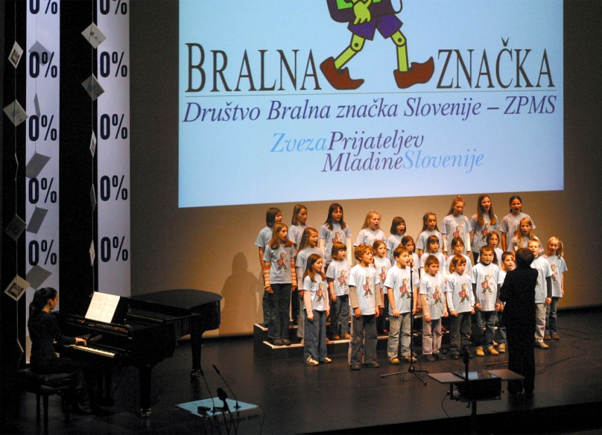
The event marking the 45th anniversary of The Reading badge (I. Lapajne)

- initiated in the school year 1960/1961
- the name and the »trade mark« of an important cultural and educational movement
- intended for preeschool children, pupils and students
- 99% of all Slovenian primary schools, 75% of all primary school children
- 6000 teachers – mentors
- also Slovene minorities, the Slovene emigrant´s children in Europe, in the countries of former Yugoslav Republic and in other parts of the world
- in the past 12 years more than 350.000 books were donated to young readers, teachers – mentors and libraries

SLIDE 2
THE READING BADGE – HOW

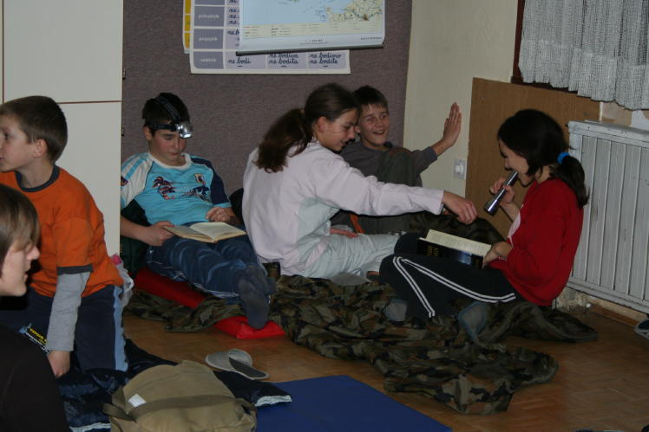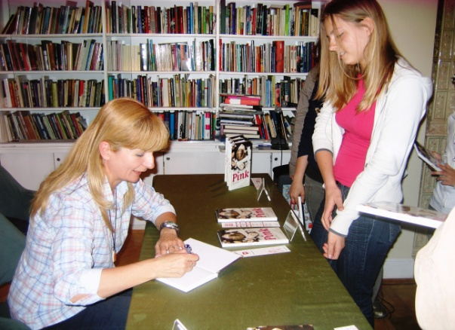
The Reading Night (archive of BZ) J. Vidmar (writer for children and young) signing her book
(archive of BZ)
A young reader:
- is given a full guidance over a number of years
- the teacher - mentor gives at his disposal a long list of books
- reading is followed by conversation or some other kind of presentation guided by the mentor.
- reading and discussions books can encourage creative writing
- at the end of each reading period a cultural performance is organized where young readers are awarded with some kind of a symbolic award (material of motivational, a book, … ) and winners are taken to the theatre or a literary excursion by their mentor.

SLIDE 3
THE READING BADGE – GOALS
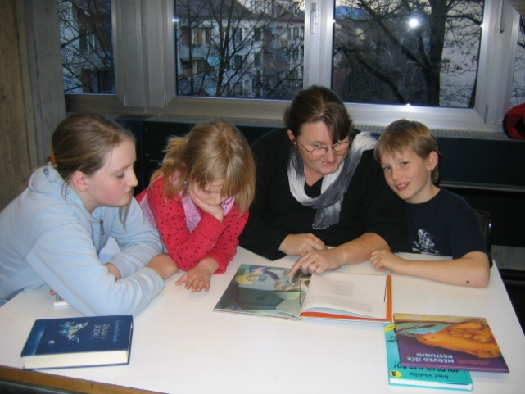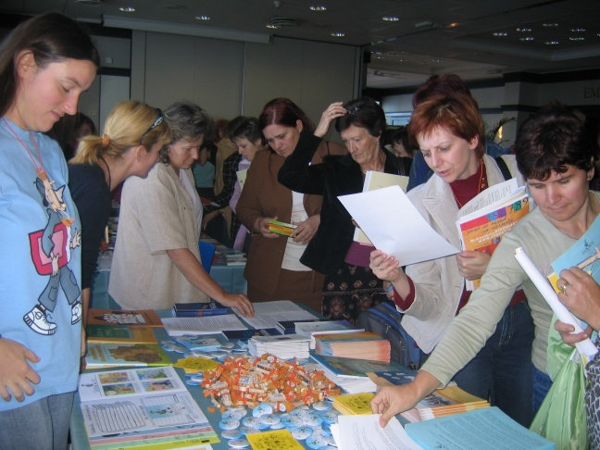
Familiy Reading (Schwitzerland 2008, archive of BZ) Teachers – mentors educating (archive of BZ)

- to develop family reading
- to develop reading habits and reading culture among children and young people
- to raise a reader who will love and enjoy reading all his/her life
- to educate and inform teachers – mentors, librarians – mentors, parents and the whole community by organizing lectures, workshops with inventive teachers, librarians, supervisors, and specialists in the field of youth literature
- help with organizing the meetings (cultural events) for young readers with important Slovene writers, illustrators and other cultural workers/artists in financial and other ways
- children and young adults are taught how to get in touch with literature
- children and young adults are helped in their search of beauty and values in the rich world of literature
- The ambitious goal of this movement is to raise a reader who will love and enjoy reading all his life.

SLIDE 4
THE READING BADGE – FINANCE AND COOPERATION

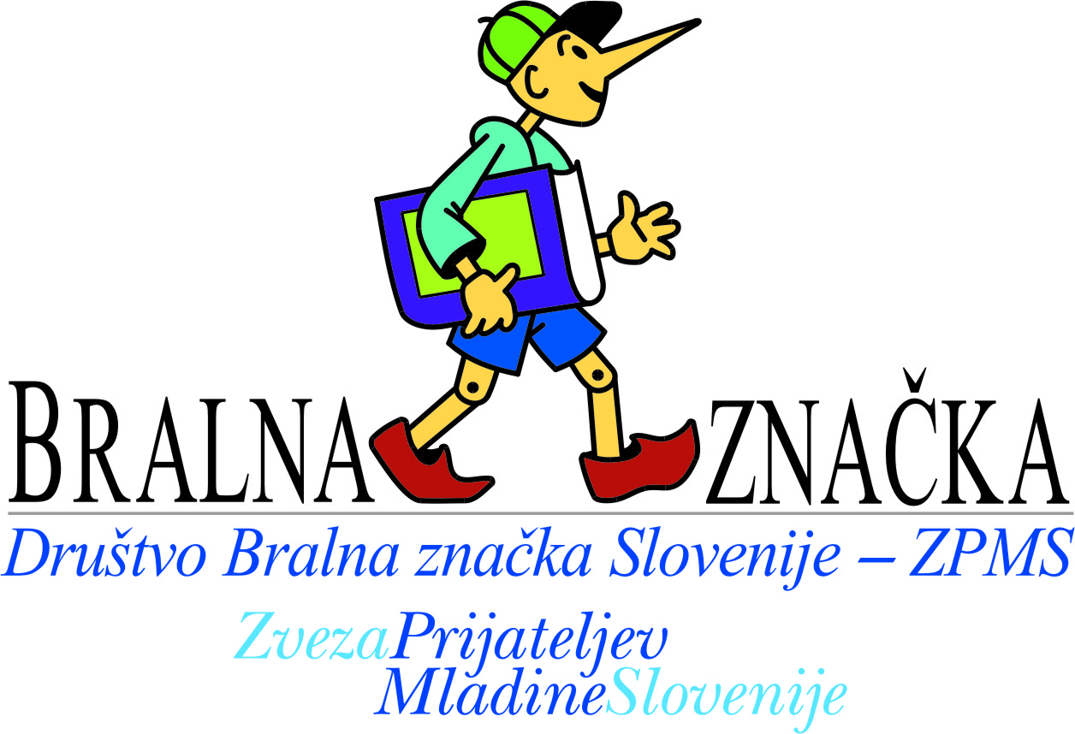

- subsidies, donors, sponsors
- cooperation with experts from libraries, Centre for Youth Literature and Librarianship, Slovenian section of IBBY, Reading Association of Slovenia, the Slovenian Writer´s Association, MC, MES and Slovenian Book Agency
- the programs for children and young people (and their parents) are free.

